Planarians are a type of flatworms with the amazing ability to self regenerate. This ability is so effective that they have been deemed “invincible under the knife”. The reason they have this ability is because they have stem cells in their body that can move to the injury site and differentiate. The planarians can be preserved in a state where the stem cells are visible. Two groups of planarians have been photographed after being put in that state, the control group, and the inhibited group which had the genes for the stem cells inhibited by introducing in double stranded RNA into the systems.

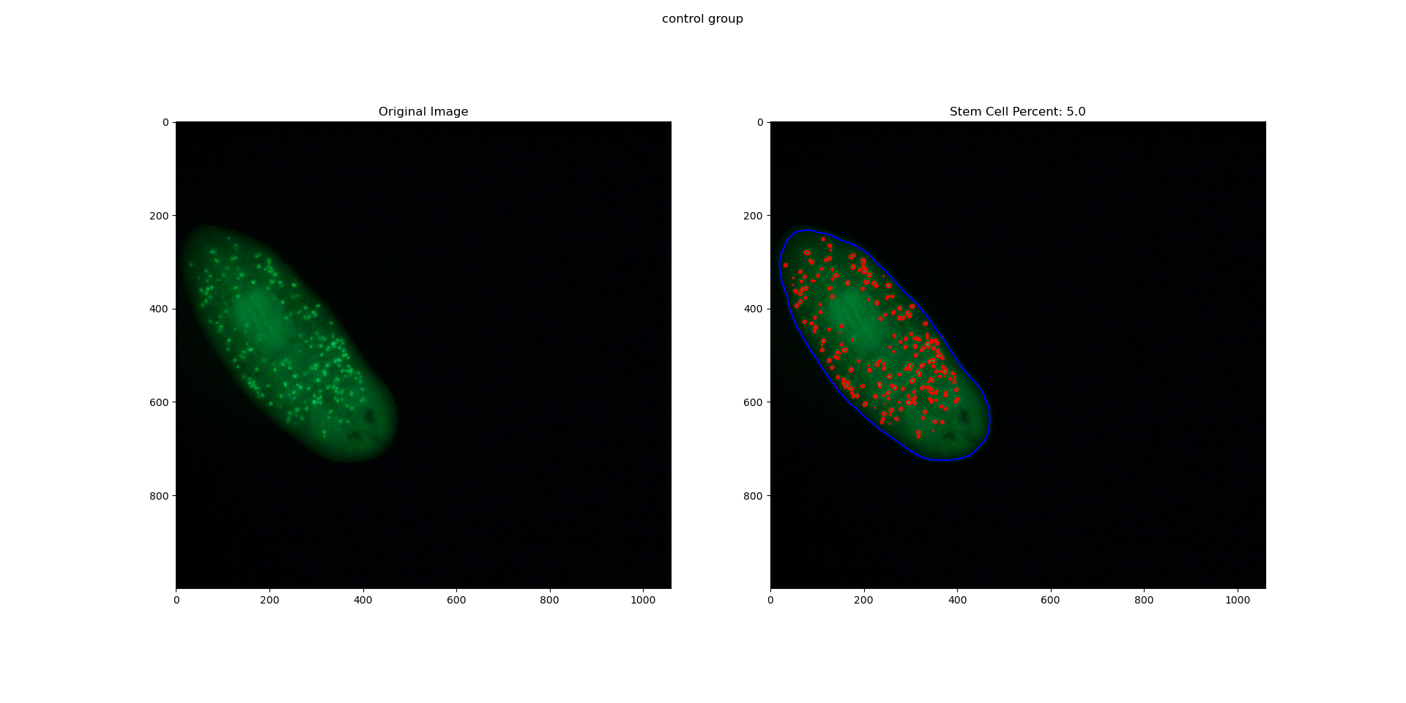

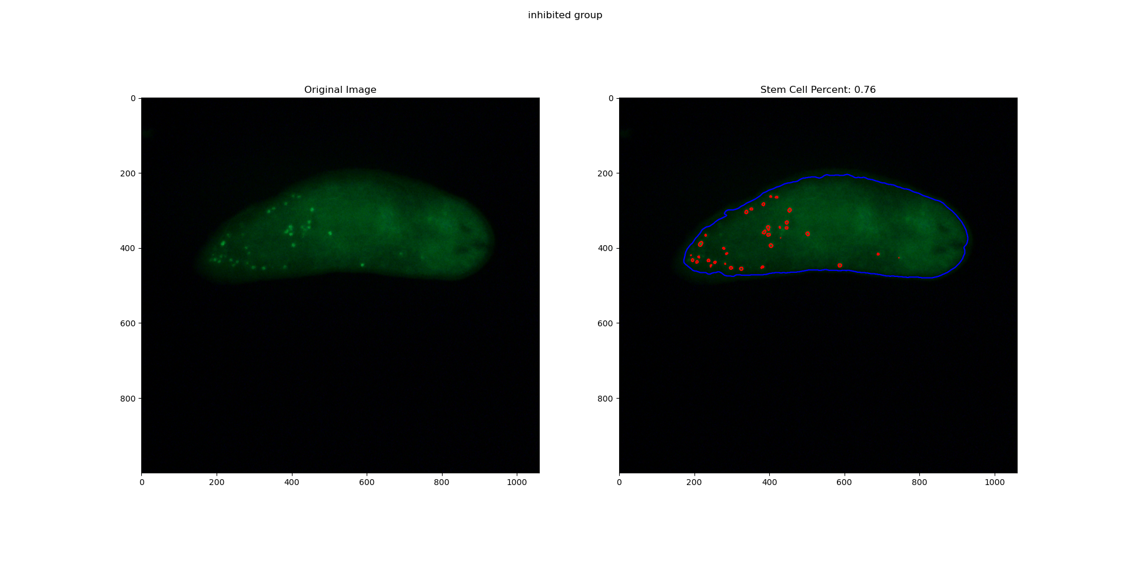

The stems cells are identified and the body of the planarians are identified. Then the pixel areas are calculated and the total area of the stem cells is divided by the total area of the planarian and the result is multiplied by one-hundred. This results in what is labeled as the stem cell percent (SCP).

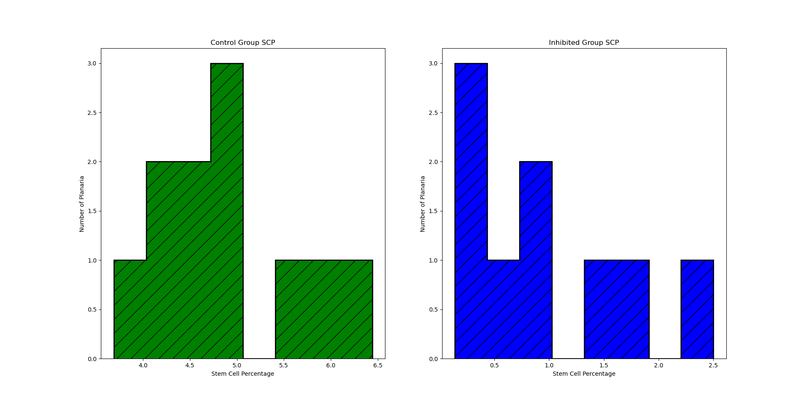

The SCP for the control group ranges from 3.69 to 6.44, has a mean value of 4.89, and has a standard deviation of 0.79. The SCP for the inhibited group ranges from 0.14 to 1.7, has a mean value of 0.95, and has a standard deviation of 0.78. A t-test was performed to determine if there is a significant difference between the means of the two groups and how they are related. This resulted in a t-statistic of 11.06 and a p-value of 1.83. This very low p-value suggests the difference between means is unlikely to have occured by chance and allows us to reject the null hypothesis of equal population means.